Calculator Active
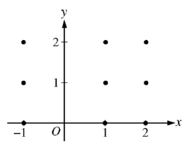
1) For a – c consider the differential equation given by: .

a) On the axes provided, sketch a slope field for the given
differential equation at the points indicated.
b) Let y = f (x) be a particular solution to the given differential equation with the initial condition f (0) = 2.
Use Euler’s method, with step size of 1, to approximate f (2).

c) Find the particular solution y = f (x) to the given differential equation with the initial condition f (0) = 2.
Use your solution to find f (2).

2. A population is modeled by a function P that satisfies the differential equation
a) If P(0) = 4, then _____ b) If P(0) = 5, then _____

c) If P(0) = 4, for what value is P is the population growing the fastest? P = _____

3. Write a differential equation to represent the rate of change of a population P(t), if the rate at which the population is changing is proportional to P – 4. Then, solve the initial value problem given that P(0) = 200, and write P in terms of t and the constant of proportionality k.

4.A radioactive substance, such as Thorium-234, decays at a rate proportional to the amount of the substance present at any time t. It takes about 24 days for a sample of Thorium-234 to decay to the point where half of the original amount remains. How long, to the nearest day, will it take for a sample of 10g of Thorium-234 to decay to 1g?

